Major Spherical Sector

Definition
# Source: AI Source: Provided by: [Data Path: Persons Table -> ID Column: 1, Name_En Column: Motasem Essam] -> From: [ChatGPT] on [7/25/2026]
A major spherical sector is a spherical sector associated with a major spherical cap—the larger portion of a sphere cut off by a plane that does not pass through the sphere’s center.
A spherical sector consists of the spherical cap and the cone-shaped region connecting the cap’s circular boundary to the center of the sphere. A major spherical sector corresponds to a major cap whose height is greater than the sphere’s radius.
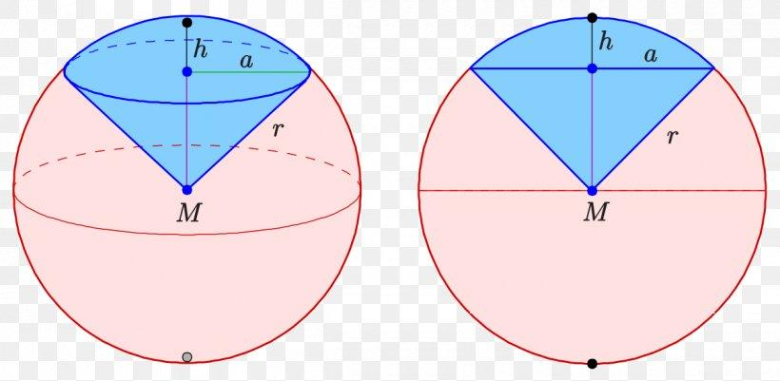
Important distinction: A major spherical sector is a three-dimensional solid. The major spherical cap is the larger portion of the sphere separated by the cutting plane; the sector additionally includes the region connecting the cap’s boundary circle to the sphere’s center.

Simple Definition
# Source: AI Source: Provided by: [Data Path: Persons Table -> ID Column: 1, Name_En Column: Motasem Essam] -> From: [ChatGPT] on [7/25/2026]
A major spherical sector is the solid formed by taking the larger spherical cap of a sphere and joining its circular boundary to the sphere’s center.
- Major means the cap is larger than a hemisphere.
- Spherical means the solid is related to a sphere.
- Sector means the cap is connected to the sphere’s center by a cone-shaped region.

Geometric Representation
# Source: AI Source: Provided by: [Data Path: Persons Table -> ID Column: 1, Name_En Column: Motasem Essam] -> From: [ChatGPT] on [7/25/2026]
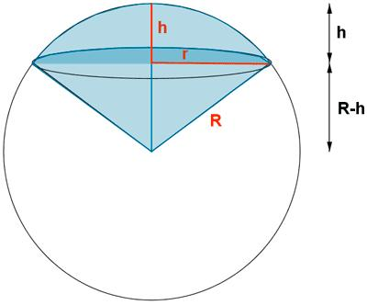
Let:
- $R$ = radius of the sphere.
- $h$ = height of the major spherical cap, measured from the cutting plane to the farthest point on the cap.
- $a$ = radius of the circular boundary of the cap.
- $O$ = center of the sphere.
For a major spherical cap:
$$R<h<2R$$
The boundary-circle radius is:
$$a=\sqrt{2Rh-h^{2}}$$
The cutting plane lies on one side of the sphere’s center, and the major cap extends around the opposite side, containing more than half of the sphere’s volume.

Types of Spherical Sectors
# Source: AI Source: Provided by: [Data Path: Persons Table -> ID Column: 1, Name_En Column: Motasem Essam] -> From: [ChatGPT] on [7/25/2026]
Spherical sectors can be classified by the spherical cap associated with them.
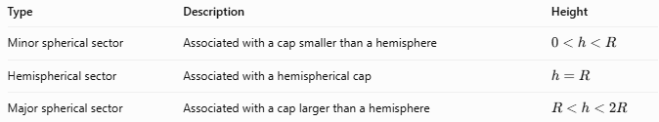
Type | Description | Height
Minor spherical sector | Associated with a cap smaller than a hemisphere | $$0<h<R$$
Hemispherical sector | Associated with a hemispherical cap | $$h=R$$
Major spherical sector | Associated with a cap larger than a hemisphere | $$R<h<2R$$

Mathematical Formulas
# Source: AI Source: Provided by: [Data Path: Persons Table -> ID Column: 1, Name_En Column: Motasem Essam] -> From: [ChatGPT] on [7/25/2026]
For the conventional spherical-sector volume formula, using the cap height $h$:
$$V=\frac{2}{3}πR^{2}h$$
The curved spherical surface area associated with the cap is:
$$A_{c}=2πRh$$
The area of the circular boundary disk is:
$$A_{b}=πa^{2}=π\left(2Rh-h^{2}\right)$$
where $a$ is the radius of the cap’s circular boundary.
Terminology note: For major caps, the phrase major spherical sector is not used uniformly across all geometry references. The volume formula above applies to the conventional sector associated with cap height $h$; it should not be interpreted as the volume of the major cap alone. The major cap’s volume is calculated separately.
Volume of the major spherical cap
The volume of the cap itself is:
$$V_\{\backslash text\{cap\}\}= \backslash frac\{\backslash pi h^2\}\{3\}(3R-h)$$
For a major cap, $R<h<2R$, so its volume is greater than half the sphere’s volume.
The volume of the entire sphere is:
$$V_{\text{sphere}}=\frac{4}{3}πR^{3}$$

Worked Example
# Source: AI Source: Provided by: [Data Path: Persons Table -> ID Column: 1, Name_En Column: Motasem Essam] -> From: [ChatGPT] on [7/25/2026]
Suppose a sphere has radius $R=6\text{ cm}$, and its major spherical cap has height $h=9\text{ cm}$.
Step 1 — Check whether the cap is major
$$6<9<12$$
Since $R<h<2R$, the cap is a major spherical cap.
Step 2 — Find the circular boundary radius
$$\begin{aligned}a&=\sqrt{2Rh-h^{2}} \\ &=\sqrt{2\left(6\right)\left(9\right)-9^{2}} \\ &=\sqrt{27}=3\sqrt{3}\end{aligned}$$
Therefore, $a≈5.20\text{ cm}$.
Step 3 — Find the major cap’s volume
$$\begin{aligned}V_{\text{cap}}&=\frac{πh^{2}}{3}\left(3R-h\right) \\ &=\frac{π{\left(9\right)}^{2}}{3}\left(18-9\right) \\ &=243π\end{aligned}$$
$$\boxed{V_{\text{cap}}≈763.41{\text{ cm}}^{3}}$$
Step 4 — Compare with the sphere’s volume
$$V_{\text{sphere}}=\frac{4}{3}π{\left(6\right)}^{3}=288π$$
The major cap occupies:
$$\frac{243π}{288π}×100=84.375\%$$
So the cap contains 84.375% of the sphere’s volume.

Major Spherical Sector vs. Related Concepts
# Source: AI Source: Provided by: [Data Path: Persons Table -> ID Column: 1, Name_En Column: Motasem Essam] -> From: [ChatGPT] on [7/25/2026]
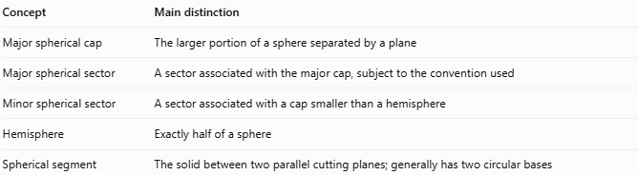
Concept | Main distinction
Major spherical cap | The larger portion of a sphere separated by a plane
Major spherical sector | A sector associated with the major cap, subject to the convention used
Minor spherical sector | A sector associated with a cap smaller than a hemisphere
Hemisphere | Exactly half of a sphere
Spherical segment | The solid between two parallel cutting planes; generally has two circular bases

Applications
# Source: AI Source: Provided by: [Data Path: Persons Table -> ID Column: 1, Name_En Column: Motasem Essam] -> From: [ChatGPT] on [7/25/2026]
- Geometry and mathematics: Studying spherical solids, cap volumes, and circular cross-sections.
- Engineering: Approximating portions of spherical tanks, domes, and rounded structures.
- Astronomy and geography: Modeling portions of spherical bodies and their cross-sections.
- Computer graphics: Representing and rendering portions of spheres.

Key Points
# Source: AI Source: Provided by: [Data Path: Persons Table -> ID Column: 1, Name_En Column: Motasem Essam] -> From: [ChatGPT] on [7/25/2026]
- A major spherical cap is larger than a hemisphere.
- Its height satisfies $R<h<2R$.
- Its circular boundary radius is $a=\sqrt{2Rh-h^{2}}$.
- Its volume is $\frac{πh^{2}}{3}\left(3R-h\right)$.
- The major spherical sector and major spherical cap are related but should not be treated as identical without defining the sector convention.

Conclusion
# Source: AI Source: Provided by: [Data Path: Persons Table -> ID Column: 1, Name_En Column: Motasem Essam] -> From: [ChatGPT] on [7/25/2026]
A major spherical sector is associated with the larger-than-hemispherical portion of a sphere. Understanding it requires distinguishing the sector from the cap itself, especially when calculating volume. For unambiguous calculations, specify whether the problem concerns the major spherical cap or a spherical sector under a stated convention.

